

8th Christmas Tournament
Poreč, 26.-29.12.2011.
Organizers: MELITA SPORT d.o.o.
Participants: Croatian basketball teams and teams from foreign countries
Date and place of tournament: Poreč, 26.-29.12.2011.

CATEGORIES
Boys | Girls | Year of birth
Junior male | Junior female | 1993/94
Cadets | Cadettes | 1995/96
Younger cadets | Younger Cadettes | 1997/98
Little school of basketball |  | 1999/00
Mix |  | 2001/02

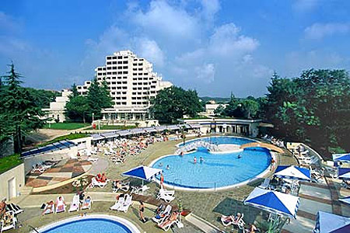 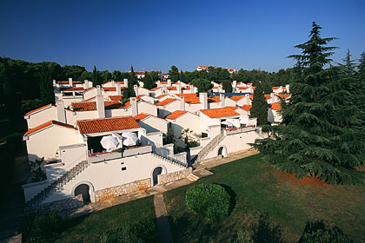 h
HOTEL VALAMAR KRISTAL -4* HOTEL VALAMAR RESIDENCE DIAMANT– 3*
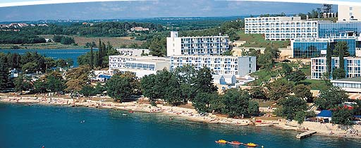
HOTEL PLAVI – 3*

Accommodation:
HOTEL „VALAMAR DIAMANT “ 4*
Price for one participant: 3 full pansions 140 € for each player or companion. All meals are served on Swedish table. Hotel has an indoor swimming pool.

HOTEL „VALAMAR DIAMANT RESIDENCE“ – 3*
Price for one participant: 3 full pansions 130 € for each player or companion. All meals are served on Swedish table. Hotel has an indoor swimming pool.

HOTEL „PLAVI“ – 3*
Price for one participant: 3 full pansions 125 € for each player or companion. All meals are served on Swedish table.
Singl room – plus 10 € per days and person
Every group of 13 participants gets one free of charge. Price of participation in the tournament is 120 € per team. Participation fee must be paid before December 1, 2011.
Parents and other companions pay the same price as the participants of the tournament.

AWARDS:
- Each team participating in the tournament gets memorial plaquettes
- Medals and trophies for three best placed teams in each category
- Special plaquettes for most valuable player (MVP)
- Special awards from sponsors
- Each participant gets a memorial t-shirt
- Other prizes and surprises

8th CHRISTMAS TOURNAMENT
December 26-29,2011.
To be returned before December 1, 2011.
CLUB: / Name _______________________________________________________________
Address: _______________________________________________________________
City : _______________________________________________________________
Country : _______________________________________________________________
Contact name - Delegation leader
________________________________________________________________
Tel: ________________________________ Fax : _______________________
E-mail: __________________________________________________________
Will participate with:
Boys:
Juniors | 1993/94
Cadets | 1995/96
Younger cadets | 1997/98
School of basketball | 1999/00
MIX | 2001/02
Girls:
Juniores | 1993/94
Cadettes | 1995/96
Younger cadettes | 1997/98
School of basketball | 1999/00
MIX | 2001/02

/Signature/
Fax: + 385 1 621 61 51
e-mail: cipasport@hotmail.com -------------------------------------------

