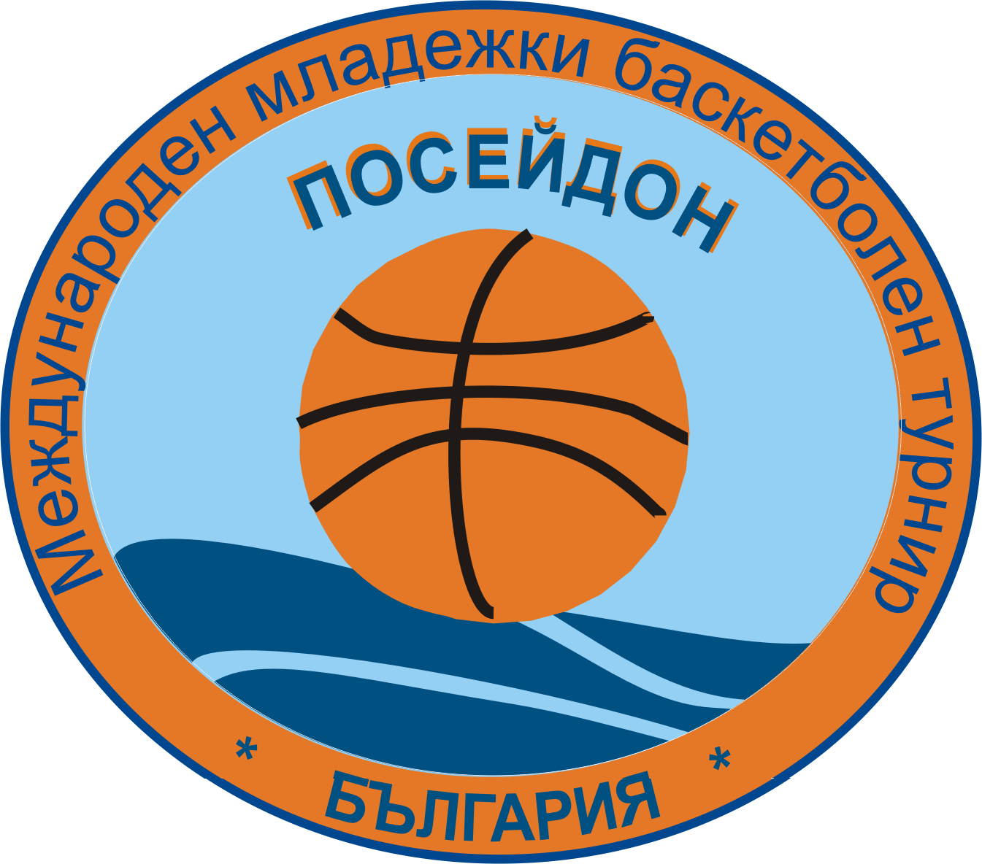
International Youth Basketball Tournament "POSEIDON"
Bulgaria, Sofia, 1606, ul.”Vladajska” 32,
tel. +359/ 2/ 852-69-73; tel./fax +359/2/ 952-44-47
e-mail : sport32@abv.bg sport@medinexbg.com www.medinexbg.com

Dear Colleagues,

We invite you to take part in the

“ POSEIDON – 2012 ”

VI International Youth Basketball Tournament
/ August 12 – 18. 2012 /

The tournament will take place in Primorsko, one of the most popular youth Black Sea resorts of Bulgaria, ultimately suitable for carrying out sporting preparation camps and training.
Tournament founders are:

Bulgarian Basketball Federation

Primorsko Municipality
Europe Foundation
Medinex Company
Sportfest Company

Tournament’s purpose: To give an opportunity for international test to the children and youth basketball teams, mastering sporting preparation of young basketball players, selection, exchange of experience, creation informal contacts between coaches and club members.

38 teams from 9 countries took part in the International Youth Basketball Tournament “ POSEIDON – 2011 ”
More details are available on our site: www.medinexbg.com

Basketball teams in the following age groups are invited for participation in the tournament:

- Girls and boys born 1996-1997, 1998-1999, 2000-2001 matches to be played from August 12 –18 .2012)

- Тhe winners will be awarded medals (1st, 2nd and 3rd places), diplomas and
T – shirts in 5 individual nominations, and cups will be given to each of the participating teams.
- The matches will be played in the sport hall of the new complex “Primorsko” and on the open playgrounds in Primorsko resort.
- The tournament’s schedule and the draw of the teams will take place at the technical conference on the opening day.

- Tournament organizers will provide referee teams and medical personnel during the matches.

ACCOMMODATE

The participants will be accommodated in 3 or 4bed rooms (with standard conveniences – beds, private bathroom with a shower and hot water, terrace) in a hotel complex of Primorsko within 150 meters from the sea. The complex has two open swimming pools, restaurant, lobby bar, exchange office, medical care unit, Internet and computer games hall, volleyball and basketball fields.

Tournament participation cost:
- 130 euro per participant staying in the standard conveniences hotels;
- 150 euro per adult included within the sportsmen group for standard accommodation;
- 180 euro per participant or adult staying in higher rank hotels (with air conditioning, TV, fridge).
The price includes:
- Six days accommodation /August 12 – 18 .2012/.
- Six full boards /breakfast, lunch and supper/
- Tournament and resort tax.
- Medical service ( medical examinations available)
- Sea rescue services on the beach.
- Use of open swimming pools and hotel beach chairs.
- 24 hours security guards.

Note: The transfer from Sofia to Burgas or Varna is paid additionally as following:
Burgas – Primorsko – Burgas – 20 Euro per person
Varna- Primorsko – Varna – 35 Euro per person( for groups of minimum 14 persons)

Note:One group leader is accepted by the organizers free of charge in groups of 15 participants. Two group leaders are accepted free of charges in groups of 25 participants.

The application for the participation in the Poseidon’2012 should be sent to the organizing committee by May 01, 2012 (the application form is attached). By July 15, 2012 the list of the participants (in Latin letters) with their traveling passports details should be sent to the organizers and advance payment of 10 % of the total participation cost should be transferred to the following account
FOUNDATION ZPMKSP EUROPA
BIC RZBBBGSF
IBAN BG65RZBB91551468035702
Raiffeisen BANK – Bulgaria Sofia

The final payment should be performed either on the arrival day or three weeks before the arrival date to the above mentioned account.
At arriving each team has to provide their medical allowance documents as well as medical insurance of each player.

The teams may choose to stay longer than the period of the tournament (7 days). In such case the payment should be made on the basis of 22 euro per person a day.

The organizers may regard also the organization of training camps for the teams in the resorts of Kiten and Primorsko in May, June and July.

More details are available on our site: www.medinexbg.com

ORGANIZING COMMITTEE
OF THE POSEIDON’2012 BASKETBALL TOURNAMENT

